ADRIAN TURION |  | Avenue de Sainte-Clotilde 9  1205 Geneva, Switzerland | 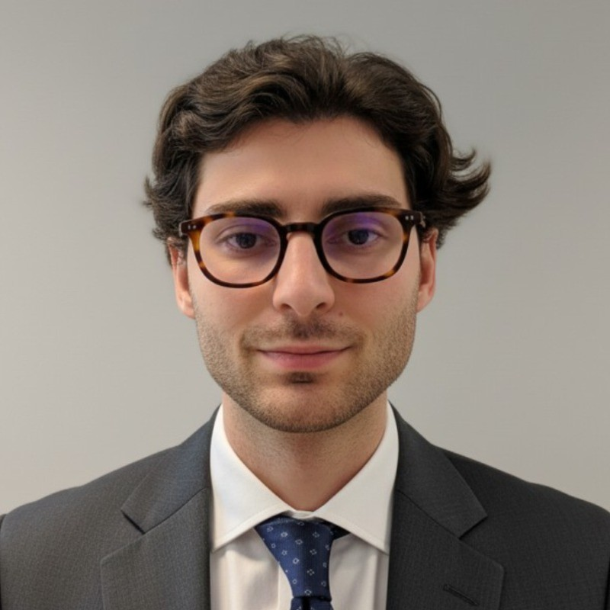
turionadrian@gmail.com | Swiss national | 10.11.2000 |  | +41 77 262 37 96
INTRODUCTION
M&A analyst based in Geneva with small and mid-cap cross-border deal experience in French-speaking Switzerland, advising entrepreneurs and family-owned businesses and leveraging AI and data to scale origination and execution.
WORK EXPERIENCE
Auraïa Capital Advisory – Small & Mid Cap Cross-border M&A Boutique  Mergers & Acquisitions Analyst (Converted internship into full-time position) |  | Geneva, Switzerland  Aug 2024 – Current
- Execute small & mid-cap M&A mandates in French-speaking Switzerland and Europe (sell-side, buy-side, fundraising), advising entrepreneurs and family-owned businesses in healthcare, tech & software, services and industrials
- Lead financial analysis, valuation, CIM/teaser production and process coordination in lean deal teams, contributing to seven live mandates and four competitive pitch wins
- Built AI-driven origination infrastructure: automated buyer lists, exhaustive sector mappings and hyper-personalised outreach workflows achieving c. 25% response and 15% meeting conversion rates

RC Group – Currently under LBO with Crédit Mutuel Equity  Mergers & Acquisitions Intern |  | Paris, France  Feb 2024 – Aug 2024
- Worked directly with the CEO of the Healthcare and Retail division to design and execute the group’s buy-and-build strategy aimed at creating a French leader in point-of-sale advertising; led market mapping and engaged over 180 targets across Italy and Portugal, conducted management interviews and site visits, and supported financial analysis and investment memos that led to advanced negotiations with shortlisted targets

Europ Assistance – Subsidiary of Generali Insurance  Financial Analyst Intern |  | Geneva, Switzerland  Apr 2023 – Aug 2023
- Supported the CFO and Head of Controlling on FP&A and strategic planning, managing P&L modeling and 3-year forecasts across 27 B2B contracts (~CHF 20M) and delivering market analyses and pitch materials to inform cost and growth initiatives

LEADERSHIP
- Finalist - Keyrock x McKinsey 2024: delivered a quantitative model that forecasts market disruptions using order book data, presenting actionable recommendations to Keyrock leadership and McKinsey partners under tight deadlines
- Associate - AIESEC: revived post-COVID business development by sourcing corporate leads, producing tailored pitchbooks, and negotiating three partnerships worth CHF 60K that increased volunteer placements by 40%
EDUCATION
HEC Lausanne  Master of Science in Finance |  | Lausanne, Switzerland  2021 – 2024
- Cumulative GPA: 5.2/6.0 (Top 15% of the class cohort)
- Exchange programs at Waseda University (Tokyo, Japan) and Maastricht University (Maastricht, Netherlands)
- Relevant Coursework: Corporate Finance, Valuation, M&A, Private Equity, Venture Capital
- Thesis Topic: Synergies Analysis of the Merger between American Airlines & US Airways

Bachelor of Science in Management |  | 2018 – 2021
- Cumulative GPA: 4.7/6.0

Scientific Baccalaureate with Highest Honors (16.6/20) |  | Aix-en-Provence, France
ADDITIONAL INFORMATION
Languages:  Computer:  Certifications:  Interests:  References: | French (Native, C2), Spanish (Native, C2), English (Fluent, C1), German (Business proficient, B2-C1)  Excel, PowerPoint, Macabacus, FactSet, Capital IQ, Bloomberg, VBA, AI workflows & automations  Candidate for the CFA Level I exam – February 2026 session  Geopolitics, Badminton (Provence regional finalist), Gym, Real use cases of Artificial Intelligence  Guillaume Arnaldez – Ex-Director at Auraïa Capital Advisory, guillaume.arnaldez@auraia.ch  Sacha Caravatti – CFO at Europ Assistance Switzerland, scaravatti@europ-assistance.ch

